Finding and Reporting Information
BioLink Reports and Query tools 2
Predefined reports 2
Checklist Report 2
Data Entry Statistics by User Report 3
Material for Taxon Report 3
Material for Trap Report 4
Selected Taxa List Report 5
Sites for a Taxon Report 5
Statistics Report 6
Storage Location Report 6
Taxa for Distribution Region Report 7
Taxa for Sites Report 7
Distribution maps 8
Changing the way the map looks 8
Printing and saving maps 8
The layers window 9
Query Tool 9
Using the Query Tool 9
Entering search criteria 10
The Results window 10
Exporting results 10
Saving and reusing searches 10
Search conditions 10
Comparison operators 11
Range search conditions 11
List search conditions 11
Pattern matching in search conditions 12
Searching for wildcard characters 12
Searching across multiple fields 13
Searching for taxon names, region names and storage locations 13
Searching for dates 13
‘More than one way to skin a cat’ 14
Labels 15
Creating label sets 15
Number of copies and sort order 15
Exporting label information 16
Formatting labels 16
Report Editor 17
Export options 17
Delimited Text 17
XML 17
Excel Worksheet 18
Microsoft Word 18
Microsoft Access 18
RTF Text 18

BioLink Reports and Query tools

BioLink provides a range of reports and tools for extracting and reporting information. There are five main types of these tools. Predefined reports provide quick access to commonly used information in easy to use predefined formats. Distribution maps can be produced using a single menu option. They can range in scale from worldwide to meter-based maps and can include as much or as little detail as required. The Query Tool is used to select and report information across an entire BioLink database. All available information can be searched and results can be exported in a range of formats. Labels are used extensively by all biological collections. A dedicated label production facility has been included in BioLink. Finally, the Report Editor is used to produce user-defined, text-based reports ranging from simple checklists to complete monographs. The flexibility and sophistication of this tool far exceeds anything available elsewhere.

Predefined reports
BioLink contains a number of predefined reports that can be quickly and easily generated. These reports provide commonly used information as well as an export facility to transfer data to other programs. Most reports are called directly from the Explorer’s. Simply select an item in the Explorer, open the Edit menu or click the right mouse button and select the Reports command followed by the name of the required report. Other reports are called from the Reports button on the main BioLink toolbar.
The following reports are supplied.
- Associates for Taxon Report: A report listing all associates for the selected taxon (and optionally region).
- Checklist Report: A report listing the children of a selected Taxon Explorer item. The details included in the report can be specified as well as the display order of the included taxa.
- Data Entry Statistics by User Report: A summary of the number of items created and updated by individual users.
- Material for Taxon Report: A list of material records for the selected Taxon Explorer item. Individual material records can be edited directly from this report.
- Material for Trap Report: A report of the material associated with a trap or bulk sample.
- Selected Taxa List Report: A report listing the currently selected Taxon Explorer items.
- Sites for Taxon Report: A report of the sites where material for the selected Taxon Explorer item has been collected.
- Statistics Report: A list of counts for items associated with the selected Taxon Explorer item. Included are valid and available names (sorted by rank) and number of material records.
- Storage Location Report: A list of taxa grouped by their storage location.
- Taxa for Distribution Region Report: A list of taxa known to occur in a political region (based on taxon information rather than material records).
- Taxa for Site Report: A report of the taxa for which material from the specified region or site is held in the database.

Associates for Taxon Report
A list of Associates for a given taxon can be easily produced by BioLink. To generate this list select a taxon in the Taxon Explorer and press the right mouse button and select the Associates for Taxon Report command from the Report menu. This will open the Associates for Taxon Report window with the name of the required taxon and (optionally) a region name. To enter a new taxon name or to restrict Associates to a given region (when known), find the required item in the appropriate Explorer and drag and drop its name onto the Report window. The ellipsis button to the right of each field can be pressed to quickly open the required Explorer. Once these items are properly set press the Preview button to create a formatted report for the requested information.
This report can be saved to disk (using the Save As… command on the File menu), printed (using the Print command on the File menu) or any or all of the text can be selected with the mouse and copied to the Clipboard using the Copy command on the Edit menu.

Checklist Report
The Checklist report provides a text-based report of items in the Taxon Explorer using the current classification. A number of options are available to select the details included in the report as well as the depth of the classification to display.
To open this report, select an item in the Taxon Explorer, click the right mouse button or open the Edit menu and select the Reports command followed by the Checklist Report command. Alternately, select the Checklist Report command under the Reports button on the main BioLink toolbar. This will open a window displaying a list of display options. These options include the following:
Full Hierarchy: When selected, this option includes the selected Taxon Explorer item and all of its children.
Next Level Down Only: When selected, this option includes the selected Taxon Explorer item and its immediate children only.
Include only Verified Names: When selected, only names that are verified are included in the report. This will eliminate unverified names from the report.
Include Available Names: Selecting this option will include available names in the report.
Include Literature Names: Selecting this option will include literature names in the report.
Include Rank Descriptions to Family Level: This option will include the rank before the taxon name for taxa at and above the family level.
Use User Defined Taxon Order: When this option is selected the taxa will be displayed in the order specified by the user using the Taxon Explorer’s Sort command.
Once options are set, press the Preview button. This will open a window displaying a checklist for the selected taxon with the selected options.
Information in the report can be copied to the clipboard by selecting the text to be copied and pressing Ctrl+C or using the Copy command from the Edit menu. The entire report can be saved to disk (in RTF - rich text format) by pressing the first toolbar button or selecting the Save As command from the File menu. This will open a Save As dialog box where a file name can be specified. To print the report press the second toolbar button or select the Print command from the File menu.

Data Entry Statistics by User Report
BioLink can easily produce a summary of the number of items created and updated by individual users. To generate this summary select the Data Entry Statistics by User Report command under the Reports button on the main BioLink toolbar. This will open the User Statistics Report window where the name of the user and a date range can be specified. To see a list of current users open the User combo box. Dates can be typed directly in the date fields or clicking the button to the right of the fields can open the calendar control. Once this information has been set press the Preview button to create a formatted report for the requested information.
This report can be saved to disk (using the Save As… command on the File menu), printed (using the Print command on the File menu) or any or all of the text can be selected with the mouse and copied to the Clipboard using the Copy command on the Edit menu.

Material for Taxon Report
The Material for Taxon Report provides a list of material records for a taxon. This report is especially useful in giving a quick overview of holdings for a taxon and in that the underlying data (Sites, Site Visits, Material and Taxa) can be edited directly from the report. Information in the report can be quickly reorganised by clicking on the column headings to change the sort order and columns can be reordered using drag and drop.
To open this report, select an item in the Taxon Explorer, click the right mouse button or open the Edit menu and select the Reports command followed by the Material for Taxon List command. This will open a window displaying a list of all material records for the selected taxon and any of its children. To sort the information in the report, click on a column heading. This will sort the information alphabetically by that column.
To edit the underlying information in the report, select a row, open the Edit menu or click the right mouse button and select the Edit Site, Edit Site Visit, Edit Material or Edit Taxon command. This will open a Details window with information for the request item. To export information in the report to disk, select the Export command from the Edit menu. This will open the Export Options window. Select the required report type and press the Export button. This will open a window where options for the selected export format can be specified. The options available will vary with the format selected. For further details see Export Options below.
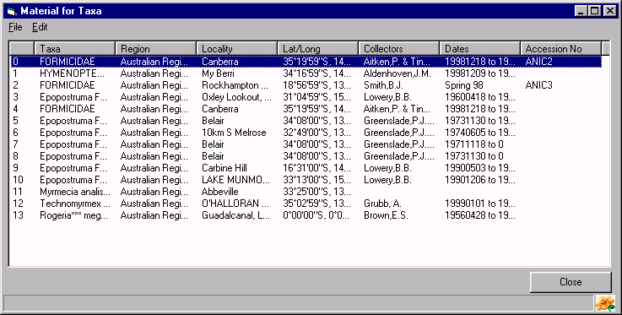

Material for Trap Report
This report provides a detailed list of material for the selected trap. It is especially useful in giving a quick overview of material for a trap and in that the underlying data (Sites, Site Visits, Material and Taxa) can be edited directly from the report. Information in the report is formatted in columns can be quickly reorganised by clicking on the column headings to change the sort order and columns can be reordered using drag and drop.
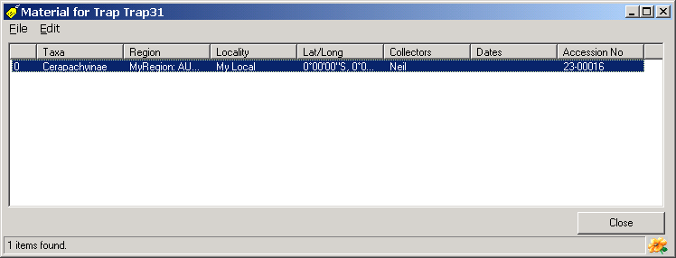
To edit the underlying information in the report, select a row, open the Edit menu or click the right mouse button and select the Edit Site, Edit Site Visit, Edit Material or Edit Taxon command. This will open a Details window with information for the selected item. To export information in the report to disk, select the Export Data command from the Edit menu. This will open the Export Options window. Select the required report type and press the Export button. A window will open where options for the selected export format can be specified. The options available will vary with the format selected. For further details see Export Options below.

Selected Taxa List Report
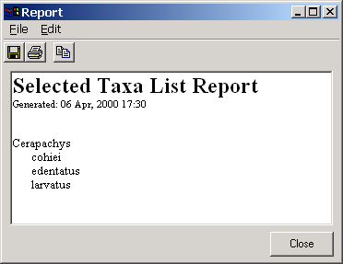
The Selected Taxa List Report provides a text-based report of the currently selected Taxon Explorer items. Any number of items can be included in the report and the items do not need to be related. By holding down the control key and clicking items with the mouse, any number of individual items can be selected. These selected items can then be included in the report.
To open this report, select items in the Taxon Explorer, click the right mouse button or open the Edit menu and select the Reports command followed by the Selected Taxa List Report command. A window will open containing a list of the selected taxa.
This information can be copied to the clipboard by selecting the text to be copied and pressing Ctrl+C or using the Copy command from the Edit menu. The entire report can be saved to disk (in RTF: rich text format) by pressing the first toolbar button or selecting the Save As command from the File menu. This will open a Save As dialog box where a file name can be specified. To print the report press the second toolbar button or select the Print command from the File menu.

Sites for a Taxon Report
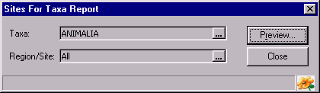
The Sites for Taxon Report provides a text-based report of the collection sites for the currently selected taxon and all of its children. The report is organised by taxon and lists details for each site.
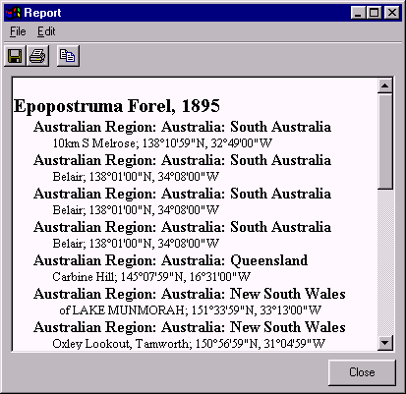
To open this report, select a taxon in the Taxon Explorer, click the right mouse button or open the Edit menu and select the Reports command followed by the Sites for Taxon Report command. Alternately, select the Sites for Taxon Report command under the Reports button on the main BioLink toolbar. A dialog box appears listing the currently selected taxon and (optionally) a geographic region. To change the taxon name or to specify a region, press the ellipsis button (with the three dots) to the right of the Taxon or Region/Site box. This will open the appropriate Explorer where the taxon name or region can be located and transferred to the dialog box using the Explorer’s Select button or drag and drop. Once these items are properly set, press the Preview button. This will open a window displaying the sites for each taxon in the region.
Information in the report can be copied to the clipboard by selecting the text to be copied and pressing Ctrl+C or using the Copy command from the Edit menu. The entire report can be saved to disk (in RTF: rich text format) by pressing the first toolbar button or selecting the Save As command from the File menu. This will open a Save As dialog box where a file name can be specified. To print the report press the second toolbar button or select the Print command from the File menu.

Statistics Report
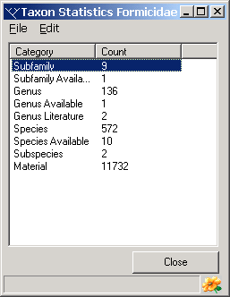
The Statistics report provides a count of items in the Taxon Explorer grouped by their type. Items include all of the children of the selected Taxon Explorer item and include material records.
To open this report, select an item in the Taxon Explorer, click the right mouse button or open the Edit menu and select the Reports command followed by the Statistics command. This will open a window displaying a list of all ranks found under the selected taxon and the number of items for each of these ranks. In additional the total number of material records for these taxa is included. To sort the information in the report, click on a column heading. This will sort the information alphabetically by that column.
Information in the report can be copied to the clipboard using Ctrl+C or the Copy command from the Edit menu. To export information in the report to disk, select the Export command from the Edit menu. Select the required report type and press the Export button. This will open the Export Options window. Select the required report type and press the Export button. This will open a window where options for the selected export format can be specified. The options available will vary with the format selected. For further details see Export Options below.

Storage Location Report
The Storage Location Report provides a text-based report of the taxa stored in the currently selected Storage Location Explorer area.
To open this report, select an area in the Storage Location Explorer (opened from the Taxa button on the main BioLink toolbar), click the right mouse button or open the Edit menu and select the Taxa for Storage Location List command. A dialog box will open where the location can be changed and the taxa to be included specified (if required). To change the location or to specify taxa, press the ellipsis button (with the three dots) to the right of the Location or Taxon field. This will open the appropriate Explorer where a new location or taxon can be located and transferred to the dialog box using the Explorer’s Select button or drag and drop. Once these items are properly set, press the Preview button. This will open a window containing a list of all taxa stored in the selected area.
Information in the report can be copied to the clipboard by selecting the text to be copied and pressing Ctrl-C or using the Copy command from the Edit menu. The entire report can be saved to disk (in RTF: rich text format) by pressing the first toolbar button or selecting the Save As command from the File menu. This will open a Save As dialog box where a file name can be specified. To print the report press the second toolbar button or select the Print command from the File menu.

Taxa for Distribution Region Report
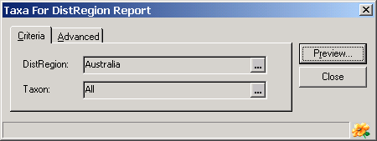
This report produces a list of taxa known to occur in a distribution (political) region. This information is entered using the Taxon Detail window called from the Taxon Explorer. For taxa recorded from a region based on specimens, see the Taxa for Site Report below.
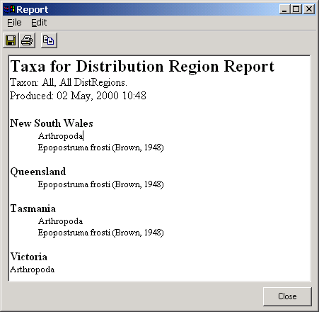
To open this report, select an area in the Distribution Region Explorer (opened from the Taxa button on the main BioLink toolbar), click the right mouse button or open the Edit menu and select the Taxa for Region List command. A dialog box will open where the distribution region can be changed and the taxa to be included specified (if required). To change the region or to specify taxa, press the ellipsis button (with the three dots) to the right of the Dist. Region or Taxon field. This will open the appropriate Explorer where a new region or taxon can be located and transferred to the dialog box using the Explorer’s Select button or drag and drop. Once these items are properly set, press the Preview button. This will open a window containing a list of all specified taxa known to occur in the selected region. The Advanced tab can be used to set a ‘timeout’ value to automatically abort long reports (set this to 0 to run a report indefinitely).
Information in the report can be copied to the clipboard by selecting the text to be copied and pressing Ctrl+C or using the Copy command from the Edit menu. The entire report can be saved to disk (in RTF: rich text format) by pressing the first toolbar button or selecting the Save As command from the File menu. This will open a Save As dialog box where a file name can be specified. To print the report press the second toolbar button or select the Print command from the File menu.

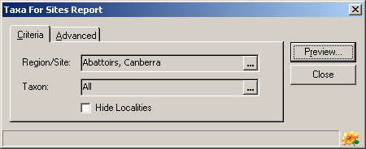
Taxa for Sites Report
The Taxa for Sites Report provides a text-based report of the taxa for which specimens are held from the specified region or site. The report list the taxa found in the region or at the site, with or without specific collection localities.
To generate this list select the Taxa for Sites Report command under the Reports button on the main BioLink toolbar. Alternately, from the Site Explorer press the right mouse button and select the Taxa for Sites Report command from the Report menu. This will open the Taxa For Sites Report window where the required region, (optionally) a taxon name and whether to hide the locality details can be entered. To enter a region or to restrict sites to a given taxon, find the required item in the appropriate Explorer and drag and drop its name onto the Report window. The ellipsis button (with the three dots) to the right of each field can be pressed to quickly open the required Explorer. If Hide Localities is checked then only taxon names are included in the report. Once these items are complete, press the Preview button to create a formatted report for the requested information. The Advanced tab can be used to set a ‘timeout’ value to automatically abort long reports (set this to 0 to run a report indefinitely).
Information in the report can be copied to the clipboard by selecting the text to be copied and pressing Ctrl+C or using the Copy command from the Edit menu. The entire report can be saved to disk (in RTF: rich text format) by pressing the first toolbar button or selecting the Save As command from the File menu. This will open a Save As dialog box where a file name can be specified. To print the report press the second toolbar button or select the Print command from the File menu.

Distribution maps
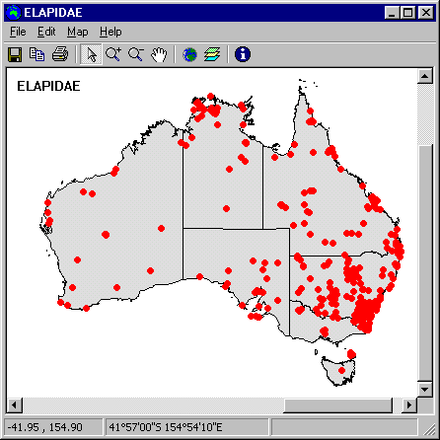
High quality distribution maps can be produced for any region and any taxon using the Taxon Explorer and the Mapping Assistant. These maps are based on ESRI shape files, providing a large range of maps at a number of scales, and available from a number of sources.
To produce a distribution map, open the Taxon Explorer and locate the taxon of interest. The chosen taxon can be of any rank, with maps for higher taxa showing records for the taxon and all of its children (for example, a family will include records for all genera and species within the family). Select the taxon name in the Explorer, click the right mouse button or open the Edit menu and select the Distribution Map… command from the Report menu.
The Distribution Map Options window will open listing the taxa to be mapped. The colour, size and style of the point to be used on the map for each taxon can be set in this window. Once the point style for each taxon has been specified, press the Plot Points button. The Mapping Assistant will then display all geocoded sites for the selected taxon/taxa.
Details concerning any of the displayed points can be retrieved by placing the mouse pointer over the point on the map, clicking the right mouse button and selecting the Edit Site, Edit Site Visit or Edit Material command from the menu. This will open the appropriate Details window for the selected item.

Changing the way the map looks
The map can be zoomed and panned using the mouse pointer and toolbar buttons. To zoom, select the Magnifying Glass with the plus sign (+) button on the toolbar. Use the left mouse button to draw a rectangle on the map. The area inside the rectangle will fill the window when the mouse left mouse button is released. To zoom out, select the Magnifying Glass with the minus sign (–) button on the toolbar and click on the map. The map will be reduced in size each time the mouse is clicked. If the map has been zoomed, the Hand button can be used to pan the map. Click the Hand button, place the mouse pointer over the map, hold down the left mouse button and move the mouse. The map will move (pan) as the mouse moves. To view the entire map, press the globe button on the toolbar. This will fill the map window with the entire map.
For details on changing the map being displayed or its colour, see The Layers Window below.

Printing and saving maps
Maps can be saved as a bitmap or enhanced metafile using the Save button on the toolbar or the Save command on the File menu. Maps can also be printed using the Print button or the Print command on the File menu. To transfer a copy of the map to the Windows clipboard, select the Copy button or the Copy Map Image command from the Edit menu. Finally, the points displayed on the map can be saved to an ESRI Shape file and transferred to a GIS package for further analysis. To create this file, open the Layers window using the Layers… command on the Map menu, select the BL_point layer and press the Save As.. button. A file name can then be specified for saving the file.

The layers window
The ‘maps’ displayed by the Mapping Assistant are composed of layers. A layer can represent a line or polygon (such as a coast line or state boundary), a series of lines or polygons (such as contour lines) or points (such as a taxon distribution). Any number of layers can be displayed at any given time. In most cases at least two layers will be used, a user-defined boundary layer and a BioLink-created point layer.
The layers displayed by the Mapping Assistant can be changed using the Layers window. To open the Layers window press the Layers button on the toolbar or select the Layers command from the Map menu. Use the Add button to add layers and the Remove button to remove them. The style used for objects in the layer is set in the Feature group. The styles available will vary with the types of objects. For example, polygons have fill colours, styles and outlines, while lines have only colours and styles. Pressing the Set Background Colour button and selecting a colour sets the background colour for the Mapping Assistant.
The order of the layers in the Layers window is same order used to display the layers on the map. Layers at the top of the list will appear above lower layers in the list. This means that if layers containing regions (such as countries) are placed above layers with points (such as sites), the points may be hidden by the regions. This problem can be solved by using the Up and Down Arrow buttons to change the order of layers in the Layers window.
The layer files must be formatted as ESRI Shape files. This is the format used by ESRI’s ArcView and ArcInfo GIS packages. Files in this format are available for a large range of areas and at a number of scales. They can be found on a number of Web sites and translators are available to convert files in other formats into the Shape file format. BioLink provides an assortment of layers but specific projects may require additional layers not provided. See The Mapping Assistant chapter for additional information.

Query Tool
The Query Tool is used to select and retrieve information from a BioLink database. Essentially any item or set of items can be searched for using a broad range of conditions, and essentially any subset of related information can be returned. The results of a search can be saved in a number of formats.
To open the Query Tool select the Query Tool command under the Reports button on the main BioLink toolbar.

Using the Query Tool
The Query Tool is composed of three items.
Field List: A list of all fields or data items in the database.
Criteria Window: A window where the search criteria and output options are specified.
Results Window: A window displaying the results of a search.
To perform a search first locate the data item(s) of interest in the Field List. Items are organised hierarchically by major group (Nomenclature, Sites, Site Visits, Material and so on) and a short description of the selected item is displayed immediately below the list. Select the required item and either double-click it or press the > button to the right of the list. Continue selecting and transferring fields until all fields required in the report have been copied to the Criteria Window. To remove a field from the Criteria Window select it and press the < button. To remove all fields press the << button.
The order of items in the Criteria Window will be the order they appear in reports. To reorder fields, select the field to be moved and use the Up and Down Arrow buttons to the left of the Window to reorder the list. By default, all fields are included in reports. To remove a field from reports but leave it in the Criteria Window uncheck the Output box for the field. This will be necessary when a field will be used to select records but that field is not otherwise required. To change the name of a field in reports, enter a new name in the Alias column for that field. To change or specify a sort order for the report click in the Sort column for a field and select Not Sorted, Ascending or Descending for that field. The report will be sorted hierarchically as specified, starting from the top of the list in the Criteria Window.
A “Distinct” clause can be added to the query. This clause will remove identical rows from the results. To add this clause, select the Distinct command under Options on the Query menu. When this menu item is checked, the Distinct clause will be added, when unchecked all rows, including duplicates, will be returned.

Entering search criteria
The final step in conducting a search is to enter the criteria used to select data. In its simplest form this can consist of a single criterion such as ‘= ‘Canberra’’. At its most complex the criteria will involve a number of fields and include pattern matching, value lists and data ranges. Most searches will lay somewhere between these two extremes. For details on constructing search criteria, see Search Conditions below.
After search criteria have been entered, the report is run by pressing the green Arrow button (fourth from the left) on the Query Tool’s toolbar. The information entered will be evaluated and if errors are found a message box will be displayed listing the error(s) found. If errors are found they will need to be repaired before the report will run. Once the criteria are entered properly and the report run, the results will be displayed in the Report Window along the bottom of the Query Tool

The Results window
Columns based on the fields in the Criteria Window display search results. The column and sort orders can be changed directly in the Report Window. To change the column orders use drag and drop to move column headings relative to each other. To sort by a column click in it’s heading. To sort by multiple columns start with the last column in the sort order and work through the columns backwards, clicking the primary sort column last. Note that these changes will not be used when exporting information and the original sort and display order specified in the Criteria Window will be used.

Exporting results
To export the results of a search click the Export Details button (fifth from the right) on the toolbar. This will open the Export Options window. Select the required report type and press the Export button. This will open a window where options for the selected export format can be specified. The options available will vary with the format selected.

Saving and reusing searches
To save a search criteria, press the Save Current Query toolbar button (third from the left). This will open a Save As dialog box where a file name can be entered to save the current query. To open a previously saved query press the Open Query toolbar button (second from the left). A File Open dialog box will open where a saved query file can be selected. To start a new query, press the New Query toolbar button (first on the left). This will reset the Query Tool, removing any previously entered criteria.

Search conditions
The information returned from a query is based on a set of search conditions or parameters. These parameters can involve a single value for a single field or a number of values scattered across a number of fields and include partial string matches and ranges of values.
The BioLink query tools support four broad types of search conditions that can be applied to individual fields, as follows:
- Comparison operators (such as =, < >, <, and >). For example, this query returns all taxa with the name ‘Iridomyrmex’.
Field: Nomenclature.Full Name
Criteria: = ‘Iridomyrmex’
- Ranges (BETWEEN and NOT BETWEEN). For example, this query returns all material records containing between two and nine specimens.
Field: MaterialPart.Number of Specimens
Criteria: between 2 and 9
- Lists (IN and NOT IN). For example, this query returns all taxa with the name of either ‘Iridomyrmex’ or ‘Camponotus’.
Field: Nomenclature.Full Name
Criteria: in (‘Iridomyrmex’, ‘Camponotus’)
- Pattern matches (LIKE and NOT LIKE). For example, this query returns all taxa with names which start with ‘Irido’
Field: Nomenclature.Full Name
Criteria: like ‘Irido*’

These search criteria are explained more fully below. Note that all searches are case-insensitive. For example, searching for ‘Portland’ and ‘portland’ will give the same results.

Comparison operators
Comparison operators are used when comparing two values. They are placed between a field and the value it is being compared with. The following operators are available:
= equal to
> greater than
< less than
>= greater than or equal to
<= less than or equal to
< > not equal to (SQL-92 compatible)
!> not greater than
!< not less than
!= not equal to

Examples
Field: Site.Locality
Criteria: = ‘Canberra’
This will return all records where the locality name is Canberra.
Field: Site.Latitude
Criteria: > 45
This will return all records where the latitude of the locality is recorded as being greater than 45 degrees (north in this case, as southern latitudes are stored as negative).

Range search conditions
A range search is one that returns all records between two specified values. The BETWEEN keyword specifies the range to search. The range is defined as being inclusive, which means that records that have the specified values will also be included. NOT BETWEEN can be used to find records outside the specified range.

Example
Field: Site.Latitude
Criteria: between -23 and 23
This will return all records where the latitude is between 23 degrees south and 23 degrees north (including those recorded as 23°00'00"S and 23°00'00"N).

List search conditions
The IN keyword finds records that match any one of a list of values. The items following the IN keyword must be separated by commas and be enclosed in parentheses (wildcards are not supported).
Example
Field: Nomenclature.Full Name
Criteria: in (‘Camponotus’, ‘Notoncus’, ‘Opisthopsis’)
This will return all records with the taxonomic names Camponotus, Notoncus or Opisthopsis (but see the note under Searching for Taxon Names below).

Pattern matching in search conditions
The LIKE keyword searches for records that match a specified pattern (and NOT LIKE searches for records which do not match this pattern). The pattern contains the character string to search for combined with any combination of the following four wildcards.

% any string of zero or more characters
_ any single character
[ ] any single character within the specified range (for example, [a-f]) or set (for example, [abcdef])
[^] any single character not within the specified range (for example, [^a - f]) or set (for example, [^abcdef])

Enclose the wildcard(s) and the character string in single quotation marks, for example:
- LIKE ‘Mc%’ searches for all strings that begin with the letters Mc (McBadden).
- LIKE ‘%inger’ searches for all strings that end with the letters inger (Ringer, Stringer).
- LIKE ‘%en%’ searches for all strings that contain the letters en anywhere in the string (Bennet, Green, McBadden).
- LIKE ‘_heryl’ searches for all six-letter names ending with the letters heryl (Cheryl, Sheryl).
- LIKE ‘[CK]ars[eo]n’ searches for Carsen, Karsen, Carson and Karson.
- LIKE ‘[R-Z]inger’ searches for all names ending with the letters inger that begin with any single letter from R to Z (Ringer, Singer, Tinger).
- LIKE ‘M[^c]%’ searches for all names beginning with the letter ‘M’ that don’t have the letter ‘c’ as the second letter (MacFeather).

Searching for wildcard characters
You can search for wildcard characters. There are two methods for specifying a character that would ordinarily be a wildcard:
- Use the ESCAPE keyword to define an escape character. When the escape character is placed in front of the wildcard in the pattern, the wildcard is interpreted as a character. For example, to search for the string 5% anywhere in a string, use LIKE ‘%5/%%’ ESCAPE ‘/’
In this LIKE clause, the leading and ending percent signs (%) are interpreted as wildcards, and the percent sign preceded by a slash (/) is interpreted as the % character.
- Use square brackets ([ ]) to enclose the wildcard by itself. To search for a dash (-), rather than using it to specify a search range, use the dash as the first character inside a set of brackets: LIKE ‘9[-]5’
The following shows the use of wildcards enclosed in square brackets.
LIKE ‘5[%]’ 5%
LIKE ‘5%’ 5 followed by any string of 0 or more characters
LIKE ‘[_]n’ _n
LIKE ‘_n’ an, in, on (and so on)
LIKE ‘[a-cdf]’ a, b, c, d, or f
LIKE ‘[-acdf]’ -, a, c, d, or f
LIKE ‘[ [ ]’ [
LIKE ‘]’ ]

When string comparisons are performed with LIKE, all characters in the pattern string are significant, including every leading and/or trailing blank (space). If a comparison to return all rows with a string LIKE ‘abc ‘ (abc followed by a single space) is requested, a row in which the value of that column is abc (abc without a space) is not returned. The reverse, however, is not true. Trailing blanks in the expression to which the pattern is matched are ignored. If a comparison to return all rows with a string LIKE ‘abc’ (abc without a space) is requested, all rows that start with abc and have zero or more trailing blanks are returned.

Searching across multiple fields
The above examples use a single field and search criterion to retrieve information. This is the simplest situation. In many cases it is desirable to combine several search criteria. For example, a list of taxa in a particular family and from a particular region may be needed. To perform this query, set the following information in the criterion section of the query tool.
Field: Nomenclature.Full Name
Criteria: = ‘Iridomyrmex’

Field: PoliticalRegion.Region Name
Criteria: = ‘New South Wales’
BioLink will combine these criteria using the AND operator.

Searching for taxon names, region names and storage locations
Information for taxon names, region names and storage locations are stored hierarchically. That is, they have parent-child relationships. BioLink allows two types of searches when using these items. The first search returns the requested item(s) and all of its(their) children while the second search returns only the required item(s). For example, requesting a genus using the first search will return the genus and all of its species and subspecies. This search with the second method will return only the genus (without its species and subspecies). The first type of search is the default. To specify the second type of search, add the word ONLY after the criterion.

For example, to return the genus Iridomyrmex and all of it’s species enter the following.
Field: Nomenclature.Full Name
Criteria: = ‘Iridomyrmex’

To return the genus Iridomyrmex alone without its species enter the following.
Field: Nomenclature.Full Name
Criteria: = ‘Iridomyrmex’ only

Searching for dates
BioLink uses two styles of dates. Collecting dates are stored as eight digit numbers with the first four digits representing the year, the next two the month and the final two the day. This method of storage allows partial dates to be entered and searched. Dates for data entry and modification are stored as full dates. These are appropriate in these cases as complete dates (including time of day) are always available.
To search for Collecting dates enter the required date as a string with eight characters, the first four representing the year, the next two the month and the final two the day. For partial dates enter zeros for the unknown values. Formatted dates and their BioLink equivalents are as follows:

29 January 1987 19870129
January, 1987 19870100
1987 19870000

Date of entry and modification dates can take a variety of formats but must be in standard US month-day-year order (as supported by Microsoft’s SQLServer). Examples are:
Jan. 29, 1987
Jan 29 1987
1-29-1987
1/29/1987

The following are suggestions for searching for collecting dates:
To find material collected on 6 May 1997, enter the following:
Field: SiteVisit.Start Date
Criteria: = 19970506

To find material collected between 6 May and 8 May, 1997, enter the following:
Field: SiteVisit.Start Date
Criteria: between 19970506 and 19970508

To find material collected in May 1997, enter the following:
Field: SiteVisit.Start Date
Criteria: between 19970500 and 19970531
(In fact, setting the last date to 19970599 also works.)

To find material collected on 6 May or 8 May, 1997, enter the following:
Field: SiteVisit.Start Date
Criteria: in (19970506, 19970508)

‘More than one way to skin a cat’
Constructing search criteria can be a complicated business and there are often a number of ways to achieve the same result. For example, BioLink will allow you to use the OR operator within a single field. Alternately, you can use the IN keyword. For example, this:
Field: Material.Macrohabitat
Criteria: = ‘rainforest’ or ‘woodland’
is the same as:
Field: Material.Macrohabitat
Criteria: in (‘rainforest’, ‘woodland’)

In the example given above it was suggested that to find material collected in May 1997, enter the following:
Field: SiteVisit.Start Date
Criteria: between 19970500 and 19970531

Alternately, this information can be retrieved using the following two criteria.
Field: SiteVisit.Start Date
Criteria: >= 19970500

Field: SiteVisit.Start Date
Criteria: <= 19970531

If one approach to a query doesn’t seem to be working it may be possible to try another approach which will.

Labels
Labels are used extensively in most biological collections as part of daily curation practices. Because of their importance, BioLink provides a Label Manager to assemble and manage labels. Combining the Label Manager with a word processor supporting mail merge facilities or other reporting packages provides a flexible and powerful method for generating a wide variety of label formats.
The production of specimen labels is a two step process. First a list of the desired labels is compiled, and second this list is exported for final formatting and printing using a word processor or other report generator. The Label Manager and Export Options window assists in both of these tasks.

Creating label sets
Labels can be created based on information derived from Regions, Sites, Site Visits and Material. To compile a list of labels, open the Label Manager by selecting the Label Manager command from the Reports button on the main BioLink toolbar. Labels are compiled in sets. A list of the current label sets is shown on the left of the window. On the right is a list of the items present in the selected set. To create a new label set press the Add New button and enter a name for the set, or to use an existing label set select its name in the list.
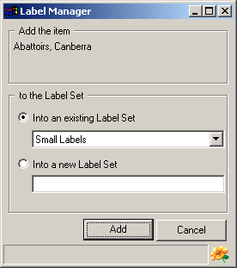
Once a label set has been selected, information can be added to it from the Site Explorer and the Site, Site Visit and Material Details windows, and the Rapid Data Entry window. To use the Site Explorer locate the required item (Site, Site Visit or Material) and add it to the list on the right of the Label Manager using drag and drop. Using the Detail windows and Rapid Data Entry, open the record of interest and then select the window’s Add to Label Set command from the Edit menu. This will open a window where a label set can be selected, or a new label set created.
An alternate way to create a label set is to base it on records entered by a user during a period of time (for example, during the previous few days). This can be done using the Load from Items Entered command on the Label Items menu of the Items menu. Running this command will open a window where a user and time period can be specified. Pressing the Load button will retrieve all records entered by the person during the specified period and transfer them to the Label manager.

Number of copies and sort order
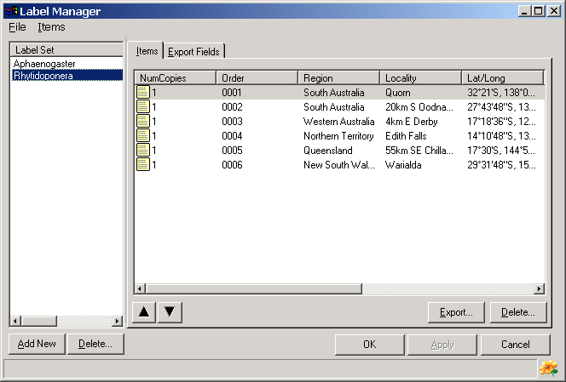
The number of copies of each label to include can be specified in the first column of the Item details panel. To change this number, select the label item or row in the right side of the Label Manager, click the right mouse button and select the Change Number of Copies command. Enter the number required and press the Enter key. The second column in the list, Order, indicates the sequence items were added to the label set. Each newly added item is given the next number in the sequence.
Labels are exported in the same order that they are displayed. To change the order either click on the headings at the top of each column to sort by that column or select an individual label and use the Arrow buttons to move it up or down the list. To resort items back to the order that they were entered, click the Order column heading.

Exporting label information
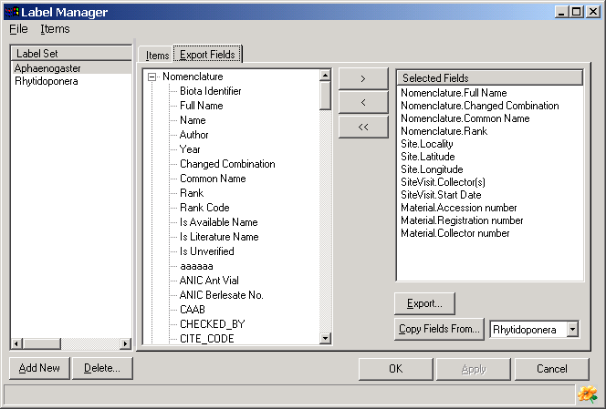
To specify the BioLink fields to export open the Export Fields tab. The required fields are moved from the list on the left to the Selected Fields list (on the right) using the top Arrow (>) button. The lower two Arrow buttons remove fields from the Selected Fields list. To export information in the label set select the Export Label Set command from the either the Set or Label Items submenu of the Items menu. This will open the Export Options window. Select the required report type and press the Export button. This will open a window where options for the selected export format can be specified. The options available will vary with the format selected. For further details see Export Options below. If the Delimited File option is selected then the separator used between individual fields should normally be a pipe ‘|’ or comma, quotes around fields should generally not be used and a header line should be included.

Formatting labels
The actual process of formatting labels will need to be done using a word processor or other reporting tool (such as MS Access). To do this with Microsoft Word use the following steps:
- Open a blank document in Word.
- On the Tools menu, click Mail Merge.
- Click Create, click Catalog, and then click Active Window.
- Click Get Data.
- Click Open Data Source and locate the file containing the exported labels.
- After you designate the data source and Word displays a message, click Edit Main Document.
- In the main document, type any text you want to be repeated with each label.
- Click where you want to insert a label item. Then click Insert Merge Field on the Mail Merge toolbar, and click the label item that you want. Items should be separated by spaces and can start on new lines if required.
- After you complete the main document and insert all of the merge fields, click Mail Merge Helper on the Mail Merge toolbar.
- Click Merge.
- In the Merge to box, click New document.
- Press Merge. A new document will be created with the label items specified in Step 8 replaced with the label information from the label export file.
- To modify the merge format, return the original document by selecting it from the Window menu.
- Repeat Step 8.
- Repeat Steps 11 and 12.
Once properly formatted, the labels can be printed using the Print command on the File menu. The merge document (containing the label item names and layout) can be saved and reused with additional label sets.

Report Editor
The Report Editor allows the generation of user defined text-based reports. The reports can be composed of any number of database items combined with free text. Database items can be based on individual items, lists of items or user-defined queries.
To open the Report Editor select the Report Editor command under the Reports button on the main BioLink toolbar. This will open the Report Editor window. For further details on using this complex feature, please contact biolink@ento.csiro.au

Export options
BioLink supports a number of formats when saving or exporting data from reports and searches. The following formats are currently supported:
Delimited Text: a delimited text file
XML: an XML-formatted file
Excel Worksheet: a Microsoft Excel worksheet
Microsoft Word: a Microsoft Word mail-merge document
Microsoft Access: a Microsoft Access database table
RTF Text: a RTF-formatted text file
A number of options are available for each of these formats. Details of the available formats are as follows:

Delimited Text
This format exports data as delimited text with one record per row. Options include the name of the file to write data to, the type of delimiter used, whether field names should be included as a header row, and whether values should be surrounded with double quotes.

XML
The XML format used by BioLink is based on the fields in the report. An element named Row is created for each row of the report. Each Row element contains a single attribute named Number that is assigned a sequential number starting from 0 which corresponds to the report row number. Each Row element also contains a list of elements for each field in the row. The names of these elements are based on the field names (with spaces replaced with underscores). A typical XML export based on the five fields Full Name, Region Name, Locality, Latitude and Longitude would look similar to this (the XML tags are automatically included):
<XML>
<META>
<Source>Biolink XML Exporter (Version 1.0.15)</Source>
<Date>2/15/00 4:33:34 PM</Date>
</META>
<DATA>
<ROW Number=‘0’>
<Full_Name>Anillomyrmex</Full_Name>
<Region_Name>New South Wales</Region_Name>
<Locality>Pigeon House Mt., 4.5k WNW of</Locality>
<Latitude>-35.35</Latitude>
<Longitude>150.2167</Longitude>
</ROW>
</DATA>
</XML>
The Row element will be repeated for each row in the report.

Excel Worksheet
The Excel Worksheet export creates a new spreadsheet with each column in the report in a spreadsheet column and with one row per report row. Options include the name of the file to create, whether column names should be placed in the first row of the worksheet, and whether Excel should be launched with the file created during the export.

Microsoft Word
The Word export creates a Word document containing a table with a column and row for each field and row in the report. Options allow the name of the file to be specified and whether to place the field names in the first row of the table.

Microsoft Access
This export transfers the report to an Access database table and optionally runs a pre-defined report using the transferred information. Options allow the name of the database to be specified (a new database will be created if required), the name of the table to place the data in (an existing or new table can be specified) and whether a report should automatically be run for the data. Any number of existing databases can be stored on the Profiles tab and one of these can be set as the default (its name will appear as the destination on the Export tab when the Exporter is initially opened).

RTF Text
The RTF export creates an RTF-based file containing a table with a column and row for each field and row in the report. Options allow the name of the file to be specified and whether to place the field names in the first row of the table.

